**Evidence for team closely adhered to principles of scrum**

Our team is using the Scrum principles to help manage our website project development. Below shows how we organized our development and provides evidence that complied with the scrum principles. We fully utilized the cloud application to overcome the geographical constraints.

1. **Group meeting**

Our group had weekly scrum meeting at every workshop. We showed our updates to the client team, received feedback from them and finally created and assigned tasks during that day.

1. **Jira**

We fully utilized Jira to develop, create and manage our Release and Sprint plan. The story criteria and user story had been generated using agile function provided in Jira. Task allocation and schedule was carried up with Jira.

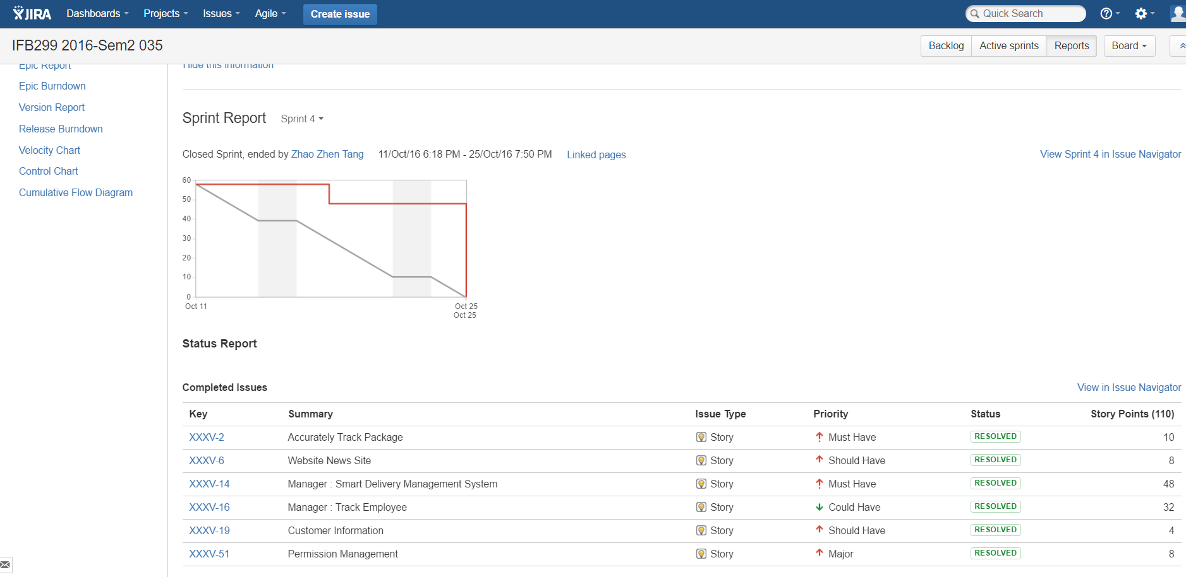

1. **Burn Down Chart (Excel)**

Jira only allow user produce burndown chart with story point. However, instead of using story point, we wish to produce burn down chart with expected completion time. So we use Microsoft Excel to produce our burn down chart.

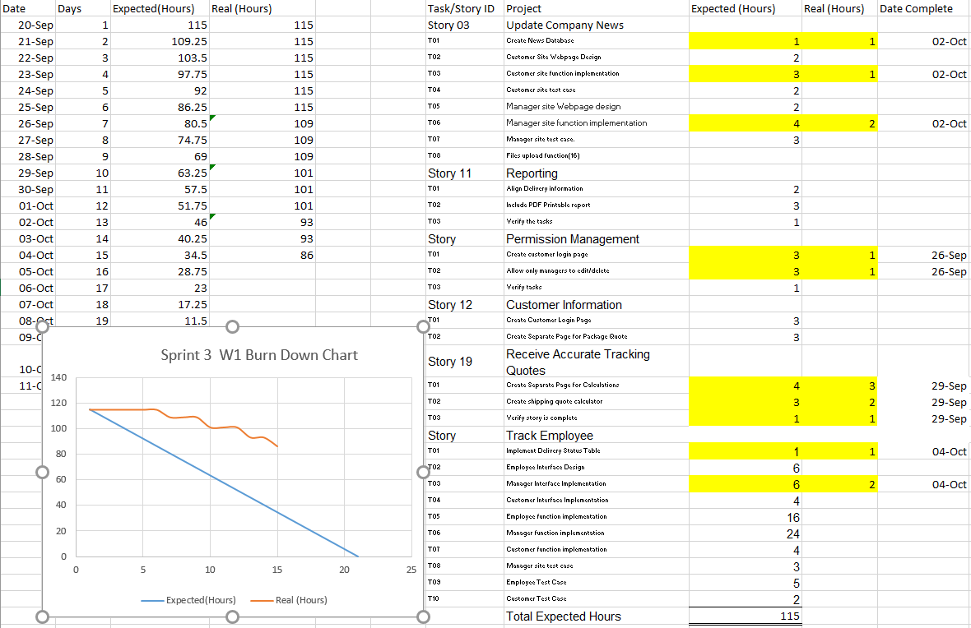

1. **Google Drive**

We created an exchange box on Google Drive to receive and share our feedback to and from the client team. We also utilized Google Doc to develop the required documentation to complete any given task.



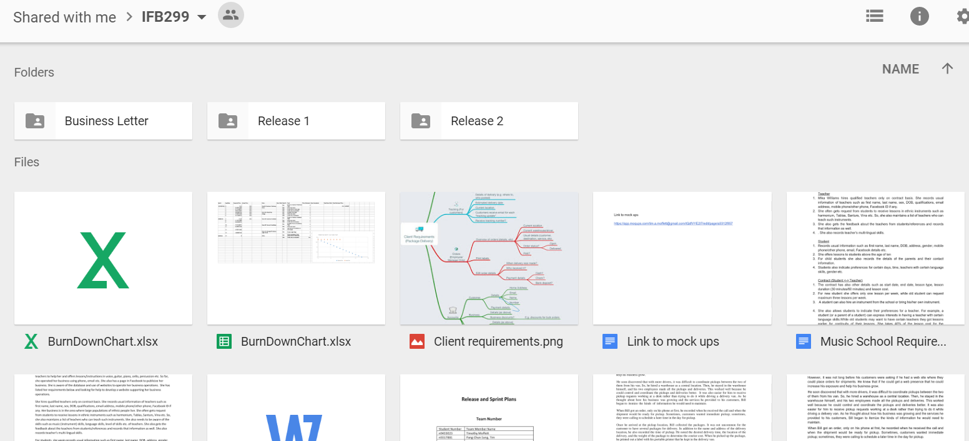

1. **Facebook messenger**

We are using Facebook messenger to communicate and have brainstorming session anytime, everywhere.

